From: https://www.unz.com/mwhitney/washingtons-plan-to-breakup-russia/

Washington's Plan to Break Up Russia
MIKE WHITNEY • OCTOBER 27, 2022 • 2,900 WORDS • 387 COMMENTS

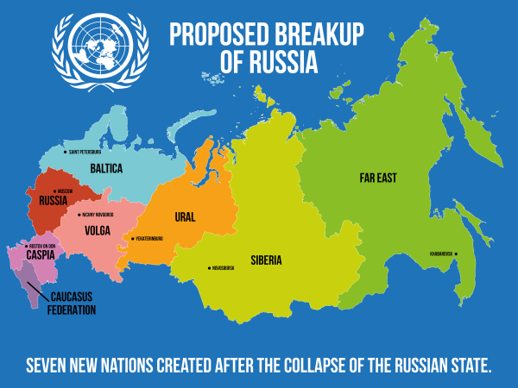
“The Western goal is to weaken, divide and ultimately destroy our nation. They are openly stating that, since they managed to break up the Soviet Union in 1991, now it’s time to split Russia into many separate regions that will be at each other’s throats.” Russian President Vladimir Putin
“Cheney ‘wanted to see the dismantlement not only of the Soviet Union and the Russian empire but of Russia itself, so it could never again be a threat to the rest of the world.’...The West must complete the project that began in 1991 …. Until Moscow’s empire is toppled, though, the region—and the world—will not be safe…” (“Decolonize Russia”, The Atlantic)
Washington’s animus towards Russia has a long history dating back to 1918 when Woodrow Wilson deployed over 7,000 troops to Siberia as part of an Allied effort to roll back the gains of the Bolshevik Revolution. The activities of the American Expeditionary Force, which remained in the country for 18 months, have long vanished from history books in the US, but Russians still point to the incident as yet another example of America’s relentless intervention in the affairs of its neighbors. The fact is, Washington elites have always meddled in Russia’s business despite Moscow’s strong objections. In fact, a great number western elites not only think that Russia should be split-up into smaller geographical units, but that the Russian people should welcome such an outcome. Western leaders in the Anglosphere are so consumed by hubris and their own blinkered sense of entitlement, they honestly believe that ordinary Russians would like to see their country splintered into bite-sized statelets that remain open to the voracious exploitation of the western oil giants, mining corporations and, of course, the Pentagon. Here’s how Washington’s geopolitical mastermind Zbigniew Brzezinski summed it up an article in Foreign Affairs:
“Given (Russia’s) size and diversity, a decentralized political system and free-market economics would be most likely to unleash the creative potential of the Russian people and Russia’s vast natural resources. A loosely confederated Russia — composed of a European Russia, a Siberian Republic, and a Far Eastern Republic — would also find it easier to cultivate closer economic relations with its neighbors. Each of the confederated entitles would be able to tap its local creative potential, stifled for centuries by Moscow’s heavy bureaucratic hand. In turn, a decentralized Russia would be less susceptible to imperial mobilization.” (Zbigniew Brzezinski, “A Geostrategy for Eurasia”, Foreign Affairs, 1997)
The “loosely confederated Russia”, that Brzezinski imagines, would be a toothless, dependent nation that could not defend its own borders or sovereignty. It would not be able to prevent more powerful countries from invading, occupying and establishing military bases on its soil. Nor would it be able to unify its disparate people beneath a single banner or pursue a positive “unified” vision for the future of the country. A confederal Russia –fragmented into a myriad of smaller parts– would allow the US to maintain its dominant role in the region without threat of challenge or interference. And that appears to be Brzezinski’s real goal as he pointed out in this passage in his magnum opus The Grand Chessboard. Here’s what he said:
“For America, the chief geopolitical prize is Eurasia…and America’s global primacy is directly dependent on how long and how effectively its preponderance on the Eurasian continent is sustained.” (“THE GRAND CHESSBOARD – American Primacy And It’s Geostrategic Imperatives”, Zbigniew Brzezinski, page 30, Basic Books, 1997)
Brzezinski sums up US imperial ambitions succinctly. Washington plans to establish its primacy in the world’s most prosperous and populous region, Eurasia. And–in order to do so– Russia must be decimated and partitioned, its leaders must be toppled and replaced, and its vast resources must be transferred to the iron grip of global transnationals who will use them to perpetuate the flow of wealth from east to west. In other words, Moscow must accept its humble role in the new order as America’s de-facto Gas and Mining Company.
Washington has never really veered from its aim of obliterating the Russian state, in fact, the recently released National Security Strategy (NSS) along with a congressional report titled “Renewed Great Power Competition: Implications for Defense—Issues for Congress”, confirm much of what we have said here, that the US plans to crush any emerging opposition to its expansion into Central Asia in order to become the dominant player in that region. Here’s an excerpt from the congressional report:
The U.S. goal of preventing the emergence of regional hegemons in Eurasia, though long-standing, is not written in stone—it is a policy choice reflecting two judgments: (1) that given the amount of people, resources, and economic activity in Eurasia, a regional hegemon in Eurasia would represent a concentration of power large enough to be able to threaten vital U.S. interests; and (2) that Eurasia is not dependably self-regulating in terms of preventing the emergence of regional hegemons, meaning that the countries of Eurasia cannot be counted on to be able to prevent, though their own actions, the emergence of regional hegemons, and may need assistance from one or more countries outside Eurasia to be able to do this dependably.” (“Renewed Great Power Competition: Implications for Defense—Issues for Congress”, US Congress)
How different is this new iteration of official US foreign policy than the so-called Wolfowitz Doctrine that was delivered prior to the War in Iraq. Here it is:
“Our first objective is to prevent the re-emergence of a new rival, either on the territory of the former Soviet Union or elsewhere, that poses a threat on the order of that posed formerly by the Soviet Union. This is a dominant consideration underlying the new regional defense strategy and requires that we endeavor to prevent any hostile power from dominating a region whose resources would, under consolidated control, be sufficient to generate global power.”
As you can see, there has been no meaningful change in the policy since Wolfowitz articulated his doctrine nearly 2 decades ago. The US foreign policy establishment still resolutely asserts Washington’s right to dominate Central Asia and to regard any competitor in the region as national security threat. This is further underscored by the fact that both Russia and China have been identified in the latest National Security Strategy as “strategic competitors” which is a deep-state euphemism for mortal enemies. Check out this excerpt from an article titled “Partitioning Russia After World War III?”:
The end goal of the US and NATO is to divide and pacify the world’s biggest country, the Russian Federation, and to even establish a blanket of perpetual disorder (somalization) over its vast territory or, at a minimum, over a portion of Russia and the post-Soviet space…
The ultimate goal of the US is to prevent any alternatives from emerging in Europe and Eurasia to Euro-Atlantic integration. This is why the destruction of Russia is one of its strategic objectives….
Redrawing Eurasia: Washington’s Maps of a Divided Russia
With the division of the Russian Federation, (the) article claims that any bipolar rivalry between Moscow and Washington would end after World War III. In a stark contradiction, it claims that only when Russia is destroyed will there be a genuine multipolar world, but also implies that the US will be the most dominant global power even though Washington and the European Union will be weakened from the anticipated major war with the Russians.” (“Partitioning Russia after World War 3”, Global Research)
​
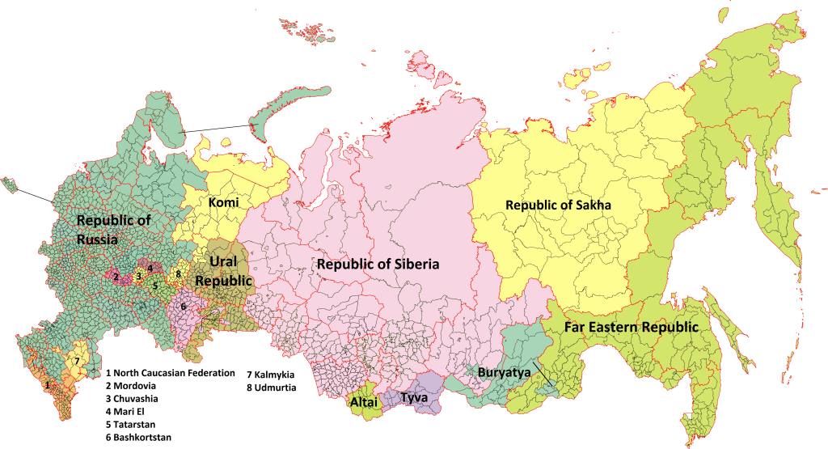

Tyva
Buryatya
Republic of Sakha
Far Eastern Republic
Washington’s relations with Russia have always been contentious but that has more to do with Washington’s geostrategic ambitions than any disruptive behavior on Moscow’s part. Russia’s only crime is that happens to occupy real estate in a part of the world the US wants to control by any means necessary. When Hillary Clinton first announced US plans to “pivot to Asia” most people thought it sounded like a reasonable scheme for shifting resources from the Middle East to Asia in order to increase US participation in the world’s fastest growing market. They didn’t realize at the time, that policymakers intended to goad Russia into a bloody ground-war in Ukraine to “weaken” Russia so that Washington could spread its military bases across the Eurasian landmass unopposed. Nor did anyone foresee the lengths to which Washington would go to provoke, isolate and demonize Russia for the express purpose of removing its political leaders and splitting the country into multiple statlets. Here’s Hillary making the case back in 2011:
“Harnessing Asia’s growth and dynamism is central to American economic and strategic interests… Open markets in Asia provide the United States with unprecedented opportunities for investment, trade, and access to cutting-edge technology…..American firms (need) to tap into the vast and growing consumer base of Asia…
The region already generates more than half of global output and nearly half of global trade…. we are looking for opportunities to do even more business in Asia…and our investment opportunities in Asia’s dynamic markets.”(“America’s Pacific Century”, Secretary of State Hillary Clinton”, Foreign Policy Magazine, 2011)
A careful reading of Clinton’s speech along with a review of the Wolfowitz Doctrine will help even the most obtuse reader to draw some obvious conclusions about the current conflict in Ukraine which has almost nothing to do with so-called “Russian aggression”, but everything to do with Washington’s plan to project power across Asia , control Russia’s massive oil and gas reserves, encircle China with military bases, and establish American domination at the epicenter of this century’s most prosperous market. Here’s Putin again:
“In order to free itself from the latest web of challenges, they need to dismantle Russia as well as other states that choose a sovereign path of development, at all costs, to be able to further plunder other nations’ wealth and use it to patch their own holes. If this does not happen, I cannot rule out that they will try to trigger a collapse of the entire system, and blame everything on that, or, God forbid, decide to use the old formula of economic growth through war.”
US foreign policy experts are shameless in their promotion of theories that threaten to trigger a direct military confrontation with Russia that could result in a nuclear exchange. In a recent “webinar for congressmen and women hosted on June 23 under the title “Decolonizing Russia.” The webinar, staffed by CIA operatives and right-wing nationalists from Ukraine and the Caucasus, effectively argued that Russia was a colonial empire that had to be broken up with the support of Washington.” (WSWS) The author explores the reasons why some experts want to brand Russia as “imperialist”? An article at the WSWS explains why:
...”the claim that Russia is “imperialist” serves a vital political function: It provides a political cover for the imperialist aggression against Russia and the war aims of the imperialist powers…. It is this strategy which the pro-NATO pseudo-left covers up for with its clamor about “Russian imperialism.” The fostering of nationalist, regionalist and ethnic tensions has been a key component of imperialist war policy for decades…..
Through a combination of NATO expansion, coups on its borders and military interventions in countries allied with Russia and China, the imperialist powers have systematically and relentlessly encircled Russia…
Indeed, if one reviews the history of the wars waged by US imperialism over the past thirty years, the unfolding war for the carve-up of Russia and China appears like a brutal inevitability. Despite their reintegration into the world capitalist system, the imperialist powers have been barred by the ruling oligarchic regimes from directly plundering the vast resources of these countries. Vying for these resources between themselves, and driven by irresolvable domestic crises, they are now determined to change this.
… the draft resolution describes the basic aims of the US war against Russia as follows: “the removal of the present regime in Russia, its replacement by an American-controlled puppet, and the breakup of Russia itself—in what is referred to as “decolonizing Russia”—into a dozen or more impotent statelets whose valuable resources will be owned and exploited by US and European finance capital.” This passage is central for understanding both the unfolding conflict and the politics of the pro-NATO pseudo-left and their insistence that Russia is an “imperialist country.” (“The historical and political principles of the socialist opposition to imperialist war and the Putin regime“, Clara Weiss, World Socialist Web Site)
As you can see, elite members of the foreign policy establishment are doggedly searching for new and more convincing justifications for a confrontation with Russia the ultimate purpose of which is to fragment the country paving the way for Washington’s strategic rebalancing or “pivot”. 20 years ago, during the Bush administration, politicians were not nearly as circumspect in their views about Russia. Former Vice President Dick Cheney, for example, made no attempt to conceal his utter contempt for Russia and was surprisingly candid about the policy he supported. Check out this excerpt from an article by Ben Norton:
Former US Vice President Dick Cheney, a lead architect of the Iraq War, not only wanted to dismantle the Soviet Union; he also wanted to break up Russia itself, to prevent it from rising again as a significant political power…. Former US Defense Secretary Robert Gates wrote that, “When the Soviet Union was collapsing in late 1991, Dick wanted to see the dismantlement not only of the Soviet Union and the Russian empire but of Russia itself, so it could never again be a threat.”…
The fact that a figure at the helm of the US government not-so-secretly sought the permanent dissolution of Russia as a country, and straightforwardly communicated this to colleagues like Robert Gates, partially explains the aggressive posturing Washington has taken toward the Russian Federation since the overthrow of the USSR.
The reality is that the US empire will simply never allow Russia to challenge its unilateral domination of Eurasia, despite the fact that the government in Moscow restored capitalism. This is why it is not surprising that Washington has utterly ignored Russia’s security concerns, breaking its promise not to expand NATO “once inch eastward” after German reunification, surrounding Moscow with militarized adversaries hell bent on destabilizing it.
Russian security services have published evidence that the United States supported Chechen separatists in their wars on the central Russian government. British academic John Laughland stressed in a 2004 article in The Guardian, titled “The Chechens’ American friends,” that several Chechen secessionist leaders were living in the West, and were even given grant money by the US government. Laughland noted that the most important US-based pro-Chechen secessionist group, the deceptively named American Committee for Peace in Chechnya (ACPC), listed as its members “a rollcall of the most prominent neoconservatives who so enthusiastically support the ‘war on terror’”:
They include
- Richard Perle, the notorious Pentagon adviser;
- Elliott Abrams of Iran-Contra fame;
- Kenneth Adelman, the former US ambassador to the UN who egged on the invasion of Iraq by predicting it would be “a cakewalk”;
- Midge Decter, biographer of Donald Rumsfeld and a director of the rightwing Heritage Foundation;
- Frank Gaffney of the militarist Centre for Security Policy;
- Bruce Jackson, former US military intelligence officer and one-time vice-president of Lockheed Martin, now president of the US Committee on Nato;
- Michael Ledeen of the American Enterprise Institute, a former admirer of Italian fascism and now a leading proponent of regime change in Iran; and
- R James Woolsey, the former CIA director who is one of the leading cheerleaders behind George Bush’s plans to re-model the Muslim world along pro-US lines.
The fact that far-right Salafi-jihadists made up a significant percentage of the Chechen insurgency didn’t bother these anti-Muslim neocons – just as Islamophobic “War on Terror” veterans had no problem supporting extremist head-chopping Takfiri Islamists in the subsequent US wars on Syria and Libya….
…. Victoria Nuland, the third-most powerful official in the Joe Biden administration’s State Department, served as Vice President Cheney’s principal deputy foreign policy adviser from 2003 to 2005. (She also helped to sponsor the violent coup in Ukraine in 2014 that toppled the democratically-elected government.) Like her mentor Cheney, Nuland is a hard-line neoconservative. The fact that he is a Republican and she works primarily in Democratic administrations is irrelevant; this hawkish foreign-policy consensus is completely bipartisan.
Nuland (a former member of the bipartisan board of directors of the NED) is also married to Robert Kagan, a patron saint of neoconservatism, and co-founder of the Project for the New American Century – the cozy home of the neocons in Washington, where he worked alongside Cheney, Donald Rumsfeld, Paul Wolfowitz, and other top Bush administration officials. Kagan was a longtime Republican, but in 2016 he joined the Democrats and openly campaigned for Hillary Clinton for president.” (“Ex VP Dick Cheney confirmed US goal is to break up Russia, not just USSR”, Ben Norton, Multipolarista)
US foreign policy is now exclusively in the hands of a small group of neocon extremists who reject diplomacy outright and who genuinely believe that America’s strategic interests can only be achieved through a military conflict with Russia. That said, we can say with some degree of certainty, that things are going to get alot worse before they get better.

